Blue Dragon Martial Arts & Synergy Fitness return to training protocols
REDUCING RISK OF COVID-19 SPREAD

- Health screening and rapid response
All students and instructors must confirm that they are well and not experiencing any symptoms of COVID-19. The Alberta Health Services COVID-19 Self-Assessment tool is available for reference. Anyone that is exhibiting any symptoms cannot enter the dojo or participate in training. If anyone begins experiencing symptoms of COVID-19 they must report it and will be immediately isolated from others and required to perform hand hygiene and put on a mask. Instructors will clean and disinfect all surfaces that the symptomatic person may have come into contact with.
- Personal hygiene
Everyone entering must perform hand hygiene before and after class and before and after using the restroom. Hand sanitizer is available in multiple areas. Everyone must bring their own water bottle.
- Parents and observers
Parents and spectators will not be allowed to enter the training space. If it is necessary to speak to an instructor, please request to do it after class.
- Arrival to class
Please do not arrive earlier than 5 minutes before class time. Participants are asked to wait outside the building if possible, to comply with physical distance and adhere to maximum gathering numbers. Please come dressed for class; change rooms will not be available.
- Physical distancing requirements
Participants and instructors will have a minimum 2m x 2m exclusive training area and equipment. Everyone is expected to “stay in their square” during class. One a class reaches capacity additional participants will not be allowed to join.
- Sanitation requirements
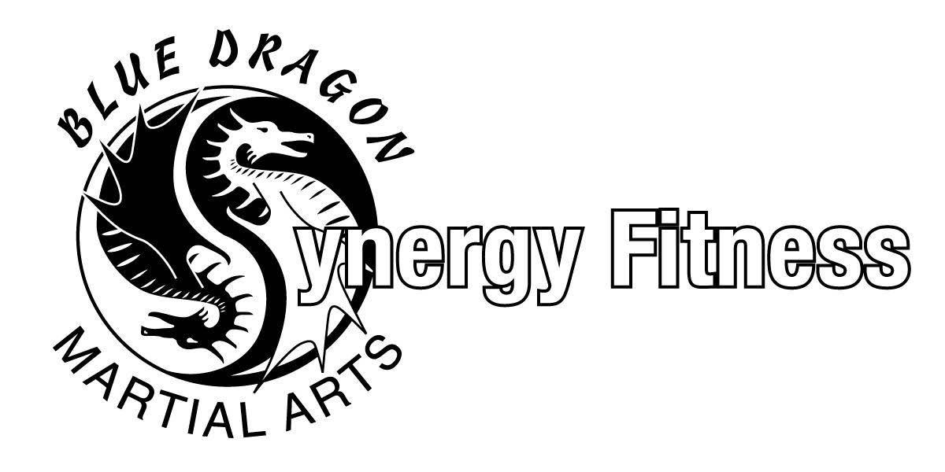
Participants will use pre-moistened wipes to clean their training area and equipment at the end of the training session. After all participants leave, instructors will spray each used square with disinfectant and allow it to air dry. Instructors will then wipe clean and spray disinfect high touch surfaces.

